Year 11

Human Biology Excretion/Digestion Test Revision

Which organ in the digestive system creates the following enzymes, and what reactions do they facilitate?

Amylase is made in the salivary glands and the pancreas, breaks starch into sugar

**Protease** is **produced** in the stomach, pancreas, and small intestine. Breaks down proteins into smaller polypeptides or single amino acids

**Lipase** is produced in the pancreas, mouth, and stomach. Used to break down fats in food so they can be absorbed in the intestines.

**Lactase** is **produced** in the small intestine and breaks down the lactic acid in milk

What is Cellulose useful for in digestion

Cellulose is a polysaccharide made of glucose polymers, which build plant fibres. Because of this, the plants possess their firmness. Humans do not digest cellulose because they do not possess certain enzymes, but it is useful for their digestion because it stimulates the work of intestines. Cellulose enhances the intestinal peristalsis. Peristalsis are series of contractions that allow the progressive movement of food through the digestive tract.

What is the function of bile, and describe its pathway in the digestive process

Bile is a fluid that is made and released by the liver and stored in the gallbladder. Bile helps with digestion. It breaks down fats into fatty acids, which can be taken into the body by the digestive tract. The gallbladder stores and concentrates bile from the liver. The bile is then released into the first section of the small intestine (the duodenum), where it helps your body to break down and absorb fats from food.

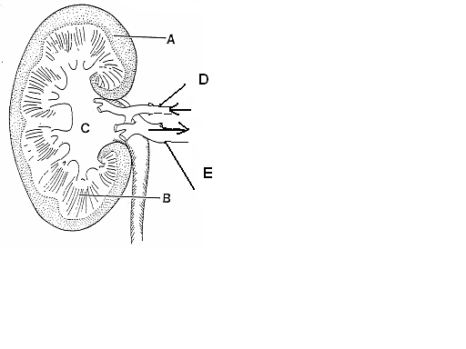Label parts of the kidney

A: Cortex

B: Medulla

C: Renal Pelvis

D: Renal Artery

E: Renal Vein

Name and specify parts of the alimentary canal that: -

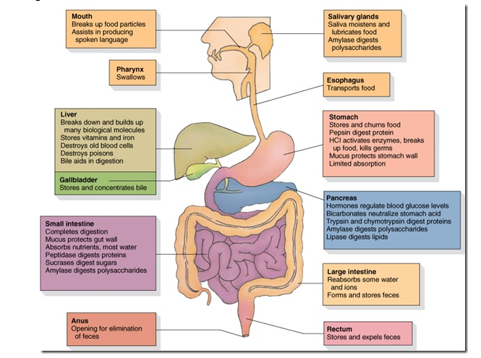

Draw and label parts of a villus and describe where they are found in the digestive system

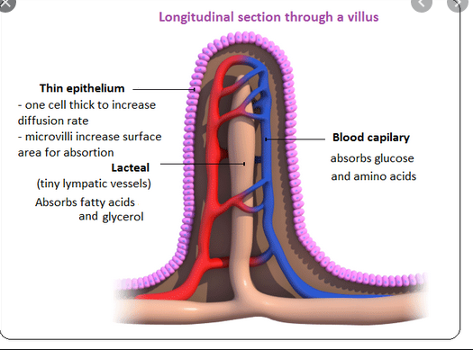

Villi are found in the small intestine

Describe villus’ function and what makes its physical attributes suitable for its function

The **villi** of the small intestine project into the intestinal cavity, greatly increasing the surface area for food absorption and adding digestive secretions.

Describe the role played by each structure in excretion

Lungs are responsible for the **excretion** of gaseous wastes, primarily carbon dioxide from cellular **respiration** in cells throughout the **body**. Exhaled air also contains **water** vapor and trace levels of some other waste gases.

Sweat glands are used to regulate temperature and remove waste by secreting water, sodium salts, and nitrogenous waste (such as **urea**) onto the skin surface.

Alimentary canal Once water, residual nutrients, and electrolytes are reabsorbed the solid waste is expelled from the body via the anal canal

Kidneys remove wastes and extra fluid from your body. Kidneys also remove acid that is produced by the cells of the body and maintain a healthy balance of water, salts, and minerals—such as sodium, calcium, phosphorus, and potassium—in the blood.

Liver the liver breaks down many substances in the blood, including toxins. The liver also excretes bilirubin — a waste product of haemoglobin catabolism — in bile. Bile then travels to the small intestine and is eventually excreted in feces by the large intestine.

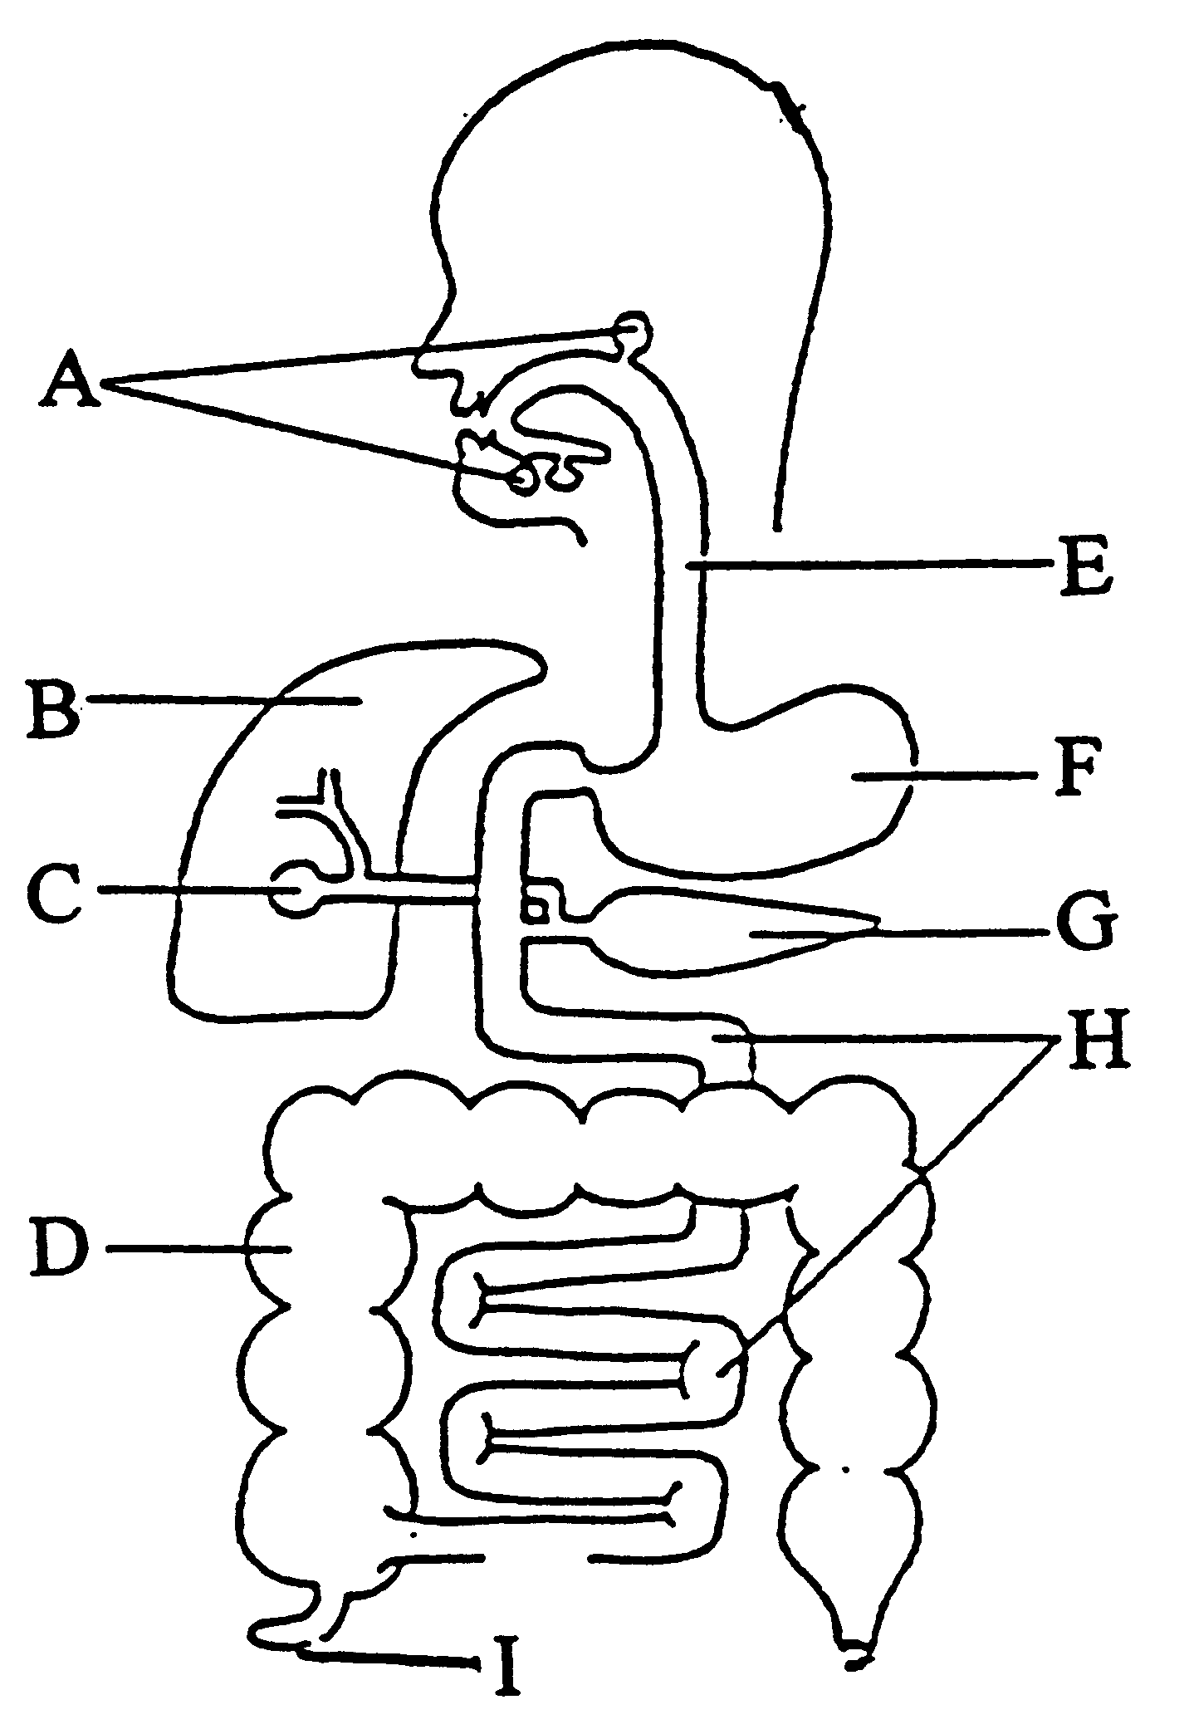Label the organs of the digestive system

A: Salivary glands

B: Liver

C: Gall bladder

D: Large Intestine

E: Oesophagus

F: Stomach

G: Pancreas

H: Small Intestine

I: Appendix

Describe where protein is mostly digested and by what enzyme

**Protein digestion** mainly occurs in the small intestine and the enzyme protease breaks down protein.

Define the following terms

Defaecation the discharge of faeces from the body

Excretion the process of eliminating or expelling waste matter

Elimination The final step in digestion is the elimination of undigested food content and waste products

Filtration is the mass movement of water and solutes from plasma to the renal tubule that occurs in the renal corpuscle.

Abdominal cavity is the space bounded by the abdominal walls, diaphragm, and pelvis and containing most of the organs of digestion, the spleen, the kidneys, and the adrenal glands.

Cortex The **renal cortex** is the outer part of the **kidney**.

Micturation Urination

Urethra the duct by which urine is conveyed out of the body from the bladder, and which in male vertebrates also conveys semen.

Ureter the duct by which urine passes from the kidney to the bladder

Renal relating to the kidneys

Urine a watery, typically yellowish fluid stored in the bladder and discharged through the urethra. It is one of the body's chief means of eliminating excess water and salt, and also contains nitrogen compounds such as urea and other waste substances removed from the blood by the kidneys.

Deamination the removal of an amino group from an amino acid or other compound.

Compare the contents of the fluids in the renal arteries to the renal veins

**Renal Veins** carry filtered blood from the kidneys **to** the posterior vena cava. **Renal Arteries** carry unfiltered blood from the aorta **to** the kidneys.

Why is ammonia converted to urea? This mechanism is important to prevent the loss of water, to maintain blood pressure, and to maintain a suitable concentration of sodium ions in the blood plasmas.

Why is urea excreted? The kidney and urinary systems help the **body** to get rid of liquid waste called **urea**. **If** your kidneys did **not** remove this waste, it would build up in the blood and cause damage to your body.

What is urine and what substances does it normally contain? **Urine** is an aqueous solution of greater than 95% water. Other constituents include urea, chloride, sodium, potassium, creatinine and other dissolved ions, and inorganic and organic compounds. Urea is a non-toxic molecule made of toxic ammonia and carbon dioxide.

Why are excess proteins deaminated? Typically, in humans, **deamination** occurs when an **excess** in **protein** is consumed, resulting in the removal of an amine group, which is then converted into ammonia and expelled via urination. This **deamination** process allows the body to convert **excess** amino acids into usable by-products.

What is the name of the structure that INITIALLY filters the blood in the kidney? Glomerulus

What happens to the urine output if the body fluids contain less water? First, decreasing **water intake** leads to an decreased **urine output**. This means that **urine** becomes more concentrated.

Describe why “detox” and “cleanse” fads are a scam.

Detoxing and cleansing – the ideas that you can flush your system of impurities and leave your organs squeaky clean and raring to go – is a scam. It’s a marketing concept designed to sell you that is cheap to make so scammers can make money.

You cannot “detox” or “cleanse” your body with anything you can drink or eat. If your body cannot detox or cleanse itself, it means your liver is failing and you need medical intervention before you die. If your lungs are not ridding your body of CO2 you have Hypercapnia which leads to seizures, loss **of** consciousness and death.

There are two types of detox: one is respectable and the other isn’t. The respectable one is the medical treatment of people with life-threatening drug addictions, where physicians assist drug addicts to physically stop drugs going into the bodies of addicts. The other is the word being hijacked by quacks and charlatans to sell a bogus treatment that allegedly detoxifies your body of toxins you’re supposed to have accumulated.

If toxins did build up in a way your body couldn’t excrete, you’re either in need of serious medical intervention, or already dead. The healthy body has kidneys, a liver, skin, even lungs that are detoxifying as we speak. No amount of juices, cleanses, or shop bought products can replace your organs. Indeed, you may be damaging your functioning organs by trying to do more than they already do.